Low Level Design

# Heart Disease Diagnostic Analysis

|  |  |
| --- | --- |
| **Written By** | Rajnish Ranjan Sinha |
| **Document Version** | 0.3 |
| **Last Revised Date** |  |

**DOCUMENT CONTROL**

## Change Record:

|  |  |  |  |
| --- | --- | --- | --- |
| **VERSION** | **DATE** | **AUTHOR** | **COMMENTS** |
| 0.1 | 30- March -  2023 | Rajnish Ranjan Sinha | Introduction and architecture defined |
| 0.2 | 30- March -  2023 | Rajnish Ranjan  Sinha | Architecture & Architecture description appended and  updated. |
|  |  |  |  |
|  |  |  |  |

**Reviews:**

|  |  |  |  |
| --- | --- | --- | --- |
| **VERSION** | **DATE** | **REVIEWER** | **COMMENTS** |
| 0.2 | 01- April -  2023 | Author 3 | Unit test cases to be added |

**Approval Status:**

|  |  |  |  |  |  |
| --- | --- | --- | --- | --- | --- |
| **VERSION** | **REVIEW**  **DATE** | **REVIEWED BY** |  | **APPROVED BY** | **COMMENTS** |
|  |  |  |  |  |  |

**Contents**

1. **Introduction 04**
   1. **What is Low-Level Design Document? 04**

|  |  |  |
| --- | --- | --- |
| **1.2** | | **Scope 04** |
| **2.** | **Architecture 05** | |
| **3.** | **Architecture Description 07** | |
|  | **3.1** | **Data Description 07** |
|  | **3.2** | **Web Scrapping 09** |
|  | **3.3** | **Data Transformation 09** |
|  | **3.4** | **Data insertion into database 09** |
|  | **3.5** | **Connection with SQL server 09** |
|  | **3.5** | **Export Data from database 12** |
|  | **3.6** | **Deployment 12** |
| **4.** | **Unit** | **test cases 15** |

1. **Introduction**
   1. **What is Low-Level design document?**

The goal of the LDD or Low-level design document (LLDD) is to give the internal logic design of the actual program code for the House Price Prediction dashboard. LDD describes the class diagrams with the methods and relations between classes and programs specs. It describes the modules so that the programmer can directly code the program from the document.

## Scope

Low-level design (LLD) is a component-level design process that follows a step-by-step refinement process. The process can be used for designing data structures, required software architecture, source code and ultimately, performance algorithms. Overall, the data organization may be defined during requirement analysis and then refined during data design work.

# Architecture

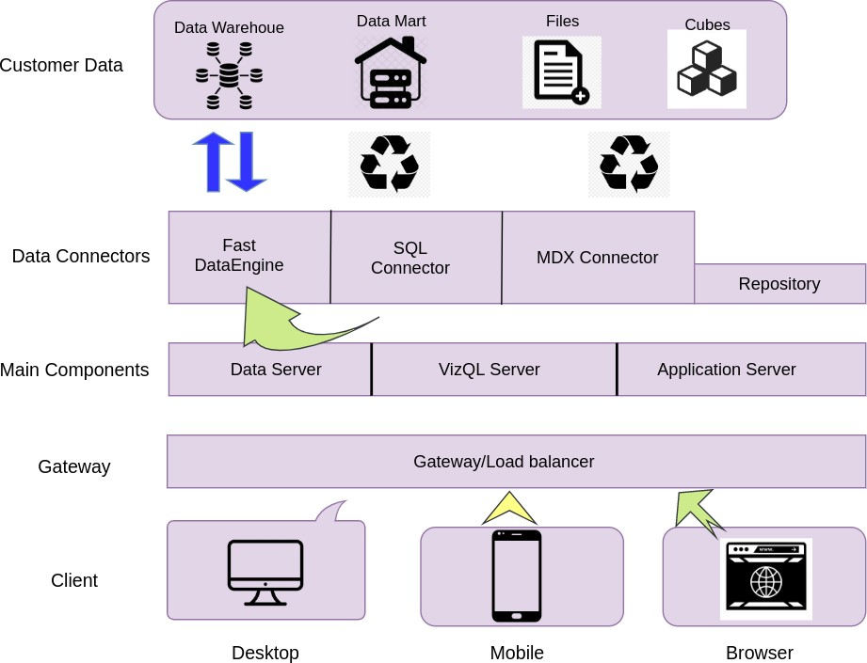

**Tableau Server Architecture**

Tableau has a highly scalable, n-tier client-server architecture that serves mobile clients, web clients and desktop-installed software. Tableau Server architecture supports fast and flexible deployments.

The following diagram shows Tableau Server’s architecture:

### Shape Description automatically generated with low confidenceLOW LEVEL DESIGN

**6**

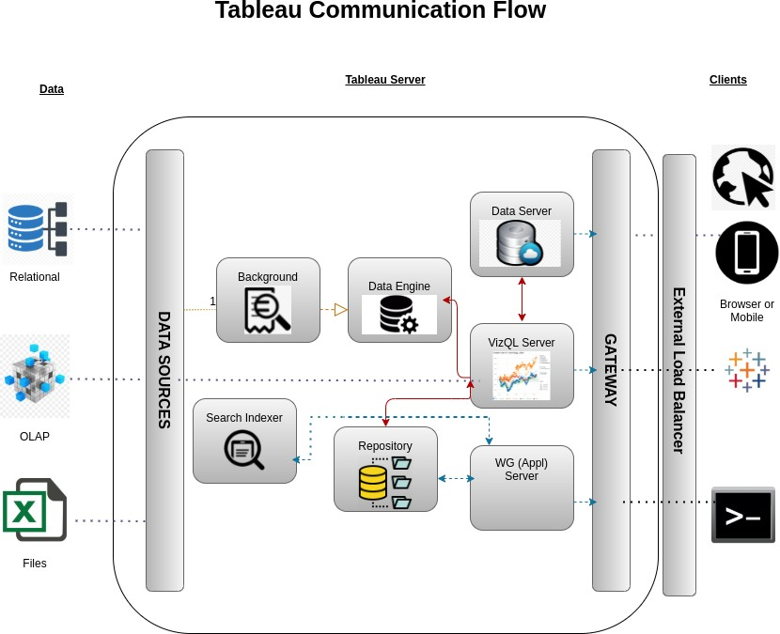

Tableau Server is internally managed by the multiple server processes.

**1. Gateway/Load Balancer**

It acts as an Entry gate to the Tableu Server and also balances the load to the Server if multiple Processes are configured.

**2) Application Server:-**

Application Server processes (wgserver.exe) handle browsing and permissions for the Tableau Server web and mobile interfaces. When a user opens a view in a client device, that user starts a session on Tableau Server. This means that an Application Server thread starts and checks the permissions for that user and that view.

1. **Repository:-**

Tableau Server Repository is a PostgreSQL database that stores server data. This data includes information about Tableau Server users, groups and group assignments, permissions, projects, data sources, and extract metadata and refresh information.

1. **VIZQL Server:-**

Once a view is opened, the client sends a request to the VizQL process (vizqlserver.exe). The VizQL process then sends queries directly to the data source, returning a result set that is rendered as images and presented to the user. Each VizQL Server has its own cache that can be shared across multiple users

1. **Data Engine:-**

It Stores data extracts and answers queries.

1. **Backgrounder:-**

The backgrounder Executes server tasks which includes refreshes scheduled extracts, tasks initiated from tabcmd and manages other background tasks.

1. **Data Server:-**

Data Server Manages connections to Tableau Server data sources

It also maintains metadata from Tableau Desktop, such as calculations, definitions, and groups.

1. **Architecture Description**
   1. **Data Description**

The Heart Disease dataset is a collection of medical records for 303 patients with varying clinical and demographic features, along with a binary label indicating the presence or absence of heart disease.

1. age: age in years
2. sex: sex (1 = male; 0 = female)
3. cp: chest pain type Value(1: typical angina Value 2: atypical angina Value 3: non-anginal pain Value 4: asymptomatic)
4. trestbps: resting blood pressure (in mm Hg on admission to the hospital)
5. chol: serum cholestoral in mg/dl
6. fbs: (fasting blood sugar > 120 mg/dl) (1 = true; 0 = false)
7. restecg: resting electrocardiographic results (Value 0: normal, Value 1: having ST-T wave abnormality (T wave inversions and/or ST elevation or depression of > 0.05 mV), Value 2: showing probable or definite left ventricular hypertrophy by Estes' criteria)
8. thalach: maximum heart rate achieved
9. exang: exercise induced angina (1 = yes; 0 = no)
10. oldpeak = ST depression induced by exercise relative to rest
11. slope: the slope of the peak exercise ST segment (Value 1: upsloping, Value 2: flat,Value 3: downsloping)
12. ca: number of major vessels (0-3) colored by flourosopy
13. thal: 3 = normal; 6 = fixed defect; 7 = reversable defect
14. num: diagnosis of heart disease (angiographic disease status)(Value 0: < 50% diameter narrowing, Value 1: > 50% diameter narrowing (in any major vessel: attributes 59 through 68 are vessels))

## Web Scrapping

Web scraping is a technique to automatically extract content and data from websites using bots. It is also known as web data extraction or web harvesting. Web scrapping is made simple now days, many tools are used for web scrapping. Some of python libraries used for web scrapping are Beautiful Soup, Scrapy, Selenium, etc.

## Data Transformation

In the Transformation Process, we will convert our original datasets with other necessary attributes format. And will merge it with the Scrapped dataset.

## Data Insertion into Database

1. Database Creation and connection - Create a database with name passed. If the database is already created, open the connection to the database.
2. Table creation in the database.
3. Insertion of files in the table

## Make the SQL connection and set up the data source

**Step 1: Configuring Tableau**

Launch Tableau on your workstation and select SQL Server from the connect column on the left. This will open a dialogue box where you need to provide the connection details for SQL Server.

To connect with tableau, you will need to provide information about the server which hosts your database. If you want to connect to a contained database, you can also specify the name of the database.

To connect with a port other than the default port, you need to specify the port and server as follows:

<server_name><port_number>

Example query: my_server 8051

There are two ways in which you can sign-in to the server, either by using Windows authentication or by using the username and password. Using the username and password becomes a must if you’re working with a password-protected server in a non-Kerberos environment.

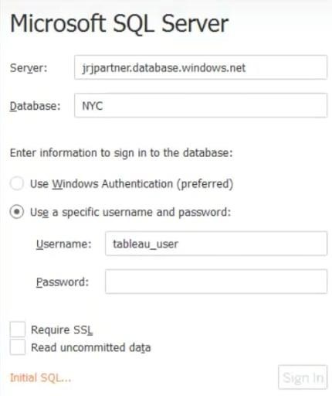

Click on Sign in to establish a connection. This will enable a connection without SSL. To establish an SSL enabled connection, click the Require SSL checkbox before you sign in.

SQL Server provides an option to let the user queries access the modified rows even before they have been committed. This option is called Read Uncommitted data. It saves time by preventing complex queries such as extract refreshes from locking the database and causing a delay. If this option is unchecked, Tableau makes use of default isolation levels.

If you want to run a specific SQL command every-time a new connection is established, you can use the Initial SQL option. This will open a dialogue box, where you can specify your desired SQL query.

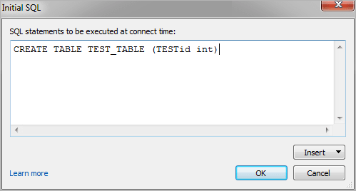

**Step 2: Configuring Data Source**

The data source page loads up after configuring the Tableau connector and successfully signing in. This is how the page looks like:

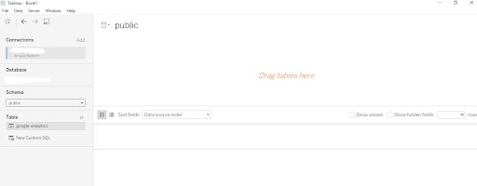

Select the data source name option and give a unique name to the database you are using. It’s considered a good practice to have a unique name as it makes it much easier for users to identify the database from which data is being fetched.

To select the desired schema, you can use the schema drop-down list from the column on the left. You can also perform a text-based search to find the desired option. Now similarly find and select the desired table and drag it onto the canvas.

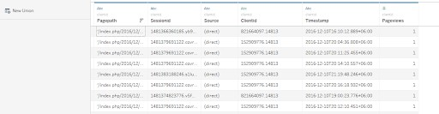

This is how you can connect SQL Server with Tableau. Now click on the sheets tab to begin the analysis.

Custom SQL features can be used to focus on specific SQL statements, rather than querying the entire database. Click on the Custom SQL option from the panel on the left. A new dialogue box will now open up, where you can provide the query you want to execute.

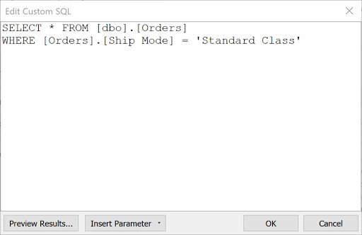

## Export Data from Database

Data Export from Database - The data in a stored database is exported as a CSV file to be used for Data Pre-processing.

## Deployment.

Once you’ve completed your dashboard, follow these steps:**- Server, Tableau Public, Save to Tableau Public As**

You may be prompted to log into your Tableau Public profile first if this is your first time publishing.

### Shape Description automatically generated with low confidenceLOW LEVEL DESIGN

**12**

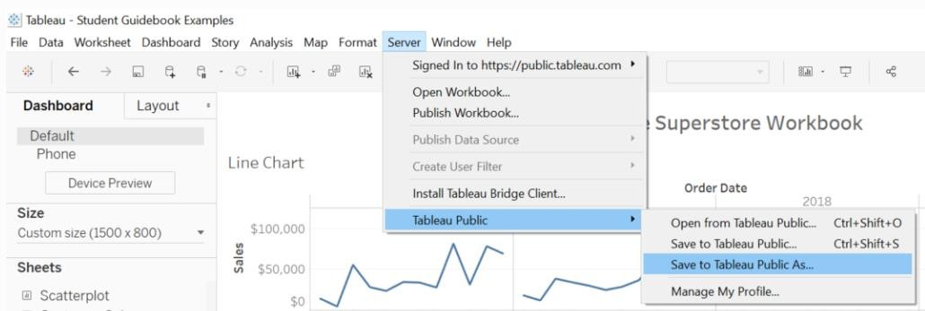

Next, fill out the title you want your viz to have and click “save”.

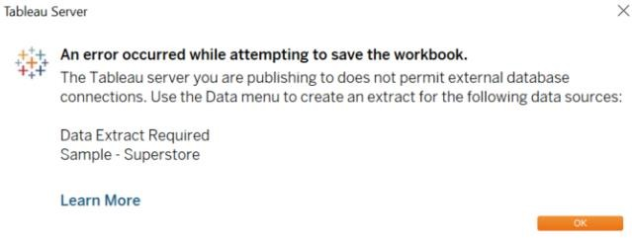

This message means that your connection to the Sample-Superstore data set is a live connection. Tableau Public cannot host live connections, so you’ll need to convert your connection to an extract (like a frozen screenshot of your data).

Here in the below screenshot, we can see that out workbook has been published to tableau public.

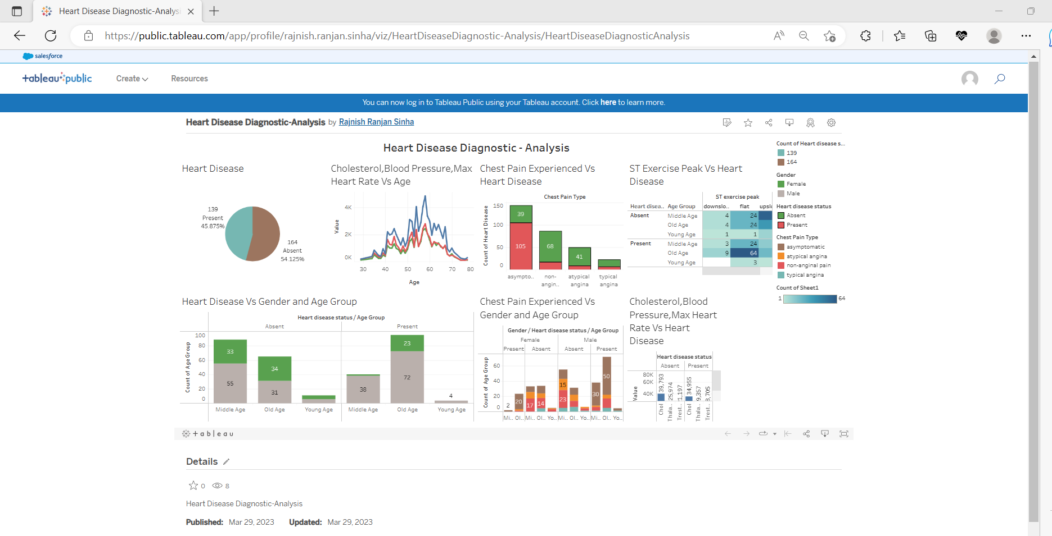

**13 LOW LEVEL DESIGN**

# Unit Test Cases

|  |  |
| --- | --- |
| **TEST CASE DESCRIPTION** | **EXPECTED RESULTS** |
| Pie chart for Heart Disease status | When clicked on the pie chart section it will show the binary status of heart disease. |
| Relation Between Cholesterol, Blood Pressure, Max Heart Rate Vs Age | When clicked on the line chart it will show the relationship between each variable. |
| Relation Between Chest Pain Experienced Vs Heart Disease | Here a bar graph which will show type of chest pain experienced by people suffering from heart disease. |
| St Exercise peak Vs Heart Disease | Sloping will be shown among age group. |
| Heart Disease Between Gender and Age Group. | The visual should show a bar graph about how heart disease varies according to gender and age group. |
| Chest Pain Experienced Vs Gender and Age group. | This plot shows a detailed overview between type of chest pain with respect to gender and age group. |
| Relation Between Cholesterol, Blood Pressure, Max Heart Rate Vs Heart Disease | This is an important visual in bar-graph which shows the category  Of Cholesterol, Blood Pressure, Max Heart Rate with respect to Heart Disease status among population |